16.AIM: Design TM using simulator to accept the input string anb2n

INPUT:

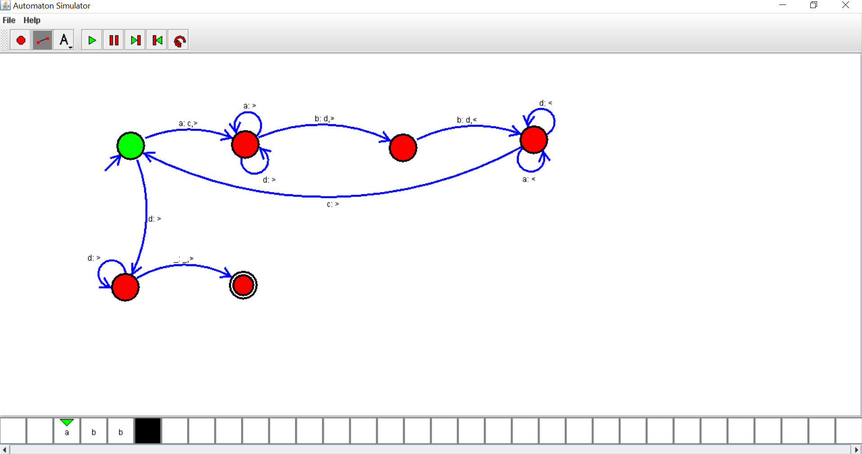

OUTPUT:

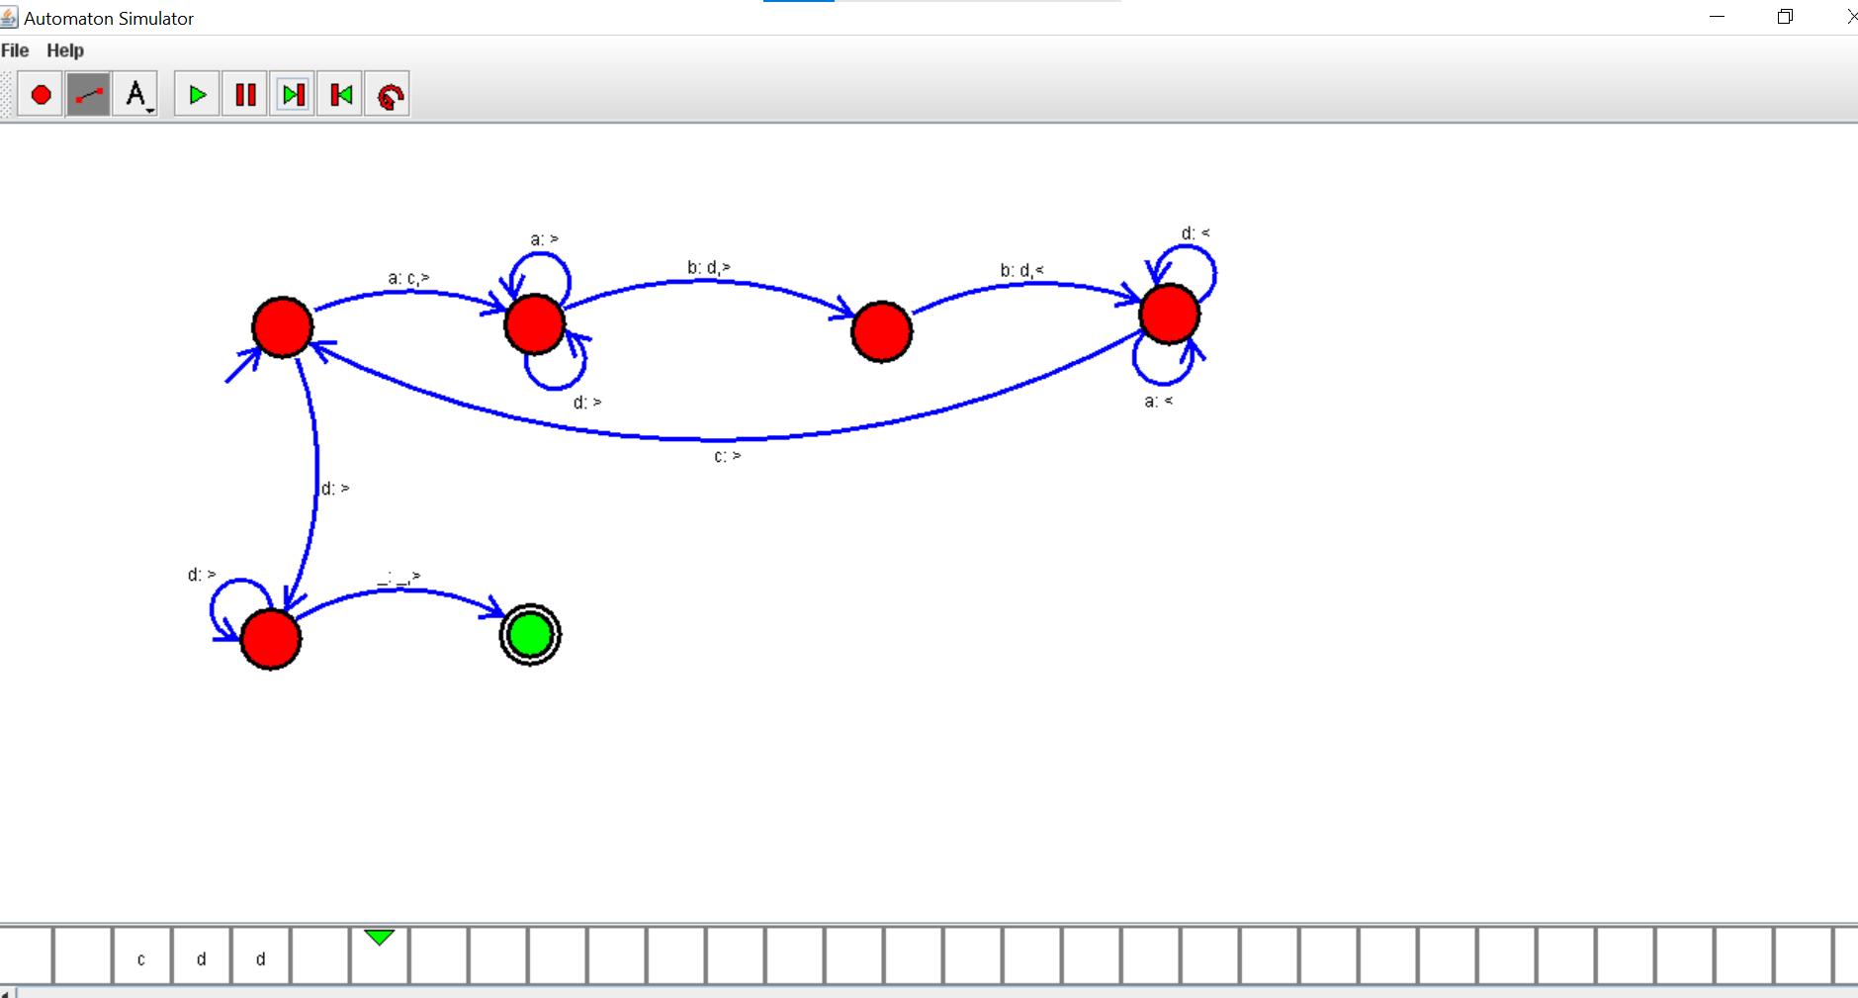

RESULT: thus designed TM using simulator to accept the input string anb2n